http://bit.ly/icomputebp19

Coding Challenge 1 – Cats like shirts
I started writing a program that lets the cat put on different color shirts. It works like this:
- If he has no shirt on and you move him to the blue box he’ll put on a blue shirt
- If he has no shirt on and you move him to the red box he’ll put on a red shirt
- If he has a shirt on and you move him to the no shirt text, he’ll take his shirt off
- If he’s already wearing a blue shirt and you move him to the red box he’ll put on a purple shirt
- If he’s already wearing a red shirt and you move him to the blue box he’ll put on a purple shirt.

To figure out which boxes he’s touched, I’ve made two variables touchedBlue and touchedRed. They are Boolean which means that they are either 1 or 0 – true or false. I also set it up so that when the cat touches one of the blue/red/no shirt sprites, the “costume change” code gets run.

- Unfortunately, I got confused when I made the program. Can you move the green blocks to the right place in the costume change block?
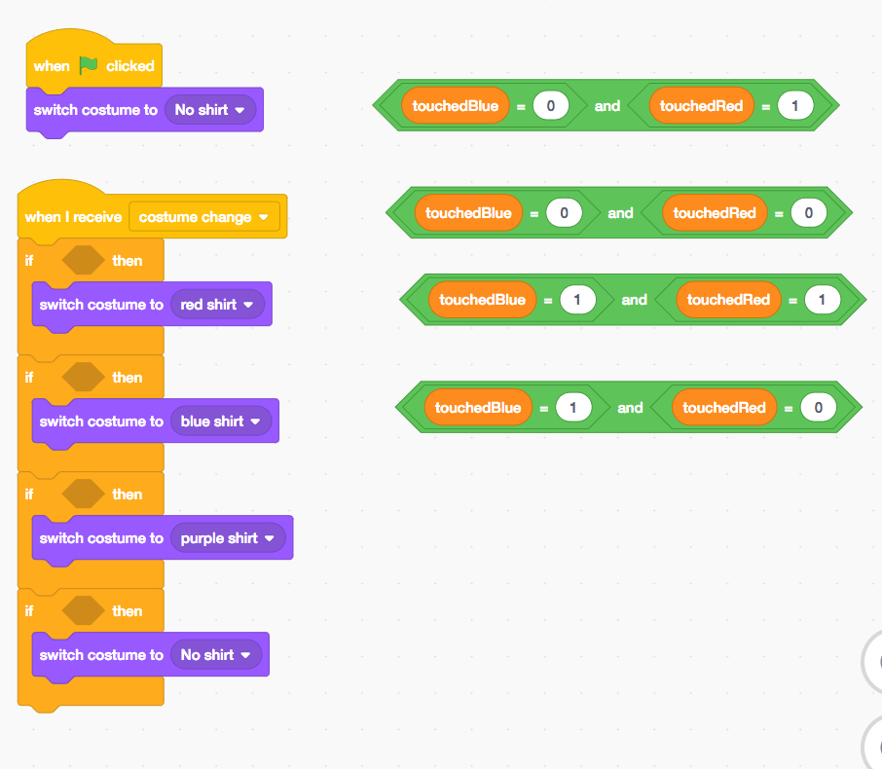
- The other problem is that I was really hungry when I was writing my program. If you look at the code for the red and blue and no shirt sprites every time I was supposed to set the variables, I typed in the name of some junk food. Can you fix this code so that it works? You should only need to change what we set touchedBlue and touchedRed to.
- If you have time, feel free to add some extras.

Coding Challenge 2 – Cats like to spin

I’m writing a program that has the cat making colored circles and spirals. There are 4 sprites that we use to control whether the cat is drawing in blue or red and how big of a spiral he should make when he goes around. Can you help me finish my program?

Take a look at the code I gave you. There are 5 sprites (cat, a blue and red buttons, and smaller and bigger buttons). I also made 3 variables. One tells the cat how many steps to walk before turning (this makes the circle bigger or smaller) and two (touchedRed and touchedBlue) to say whether we touched the blue or red sprites. I set it up so that whenever you go over one of the buttons it broadcasts (sends) the “change costume” message that tell the cat to change his shirt and the pen.

- Take a look at the code for the cat. There are four blocks just hanging out. Can you put them in the right place? Hint: When I touch the red block, the touchedRed will be 1.
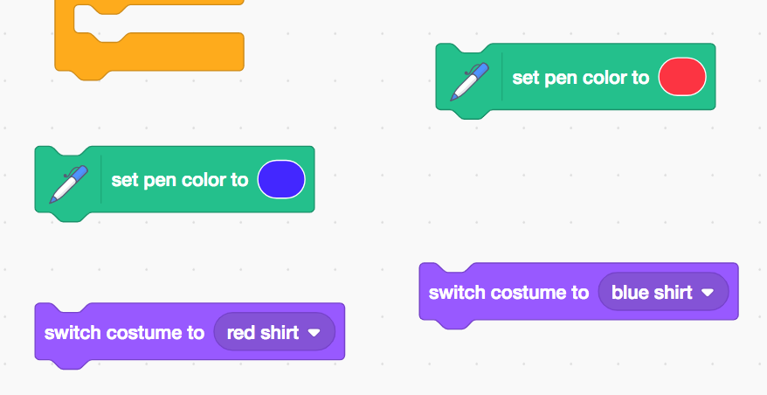

- The block for the cat is missing one of the if conditions. So right now we can only get one of the pen colors. Can you complete the missing code?
- The red and the blue sprites also need to be finished. Start with the red. Add code so that the variables (touchedRed and touchedBlue) get set to the right thing. You should be able to test your code now. Example with missing block(s):
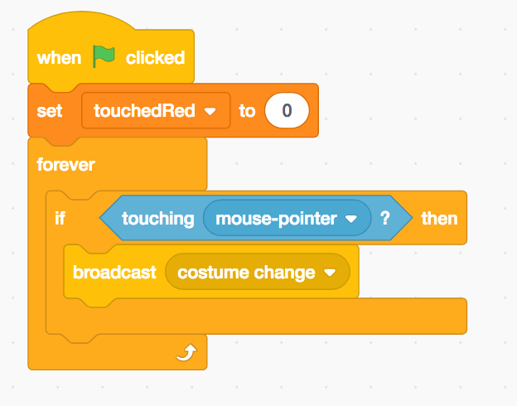
- Can you now fix the bigger sprite so that it changes the steps variable (bigger by 1 pixel) whenever your mouse goes over the text?
- Try to make the smaller sprite work (it should make steps smaller by 1)
- Finally, the code lets us make circles that are way too big or way too small. Can you modify the code so that we can’t make anything smaller than 10 steps or bigger than 30?
- If you have extra time, see if you can add other interesting variables and buttons.

